WEEK 3 TASK
Machine Learning Model Building and Training Pipeline
Methodology, executed worked example, and measured results for model selection, training, tuning, and validation in Python
Prepared by: Virtual Machine Learning Assistant Intern
Date: October 28, 2026
Environment: Python 3.12.3, scikit-learn 1.8.0, pandas 3.0.2, NumPy 2.4.4, SciPy 1.17.1, matplotlib 3.10.8
Worked example: Customer churn prediction, binary classification on 12,000 simulated telecom customers. Every number, table, and chart in Section 5 was produced by the code shown in this document.

Contents
1. Introduction
2. Model Selection
3. Training Pipeline (algorithms, metrics, cross-validation, tuning, validation strategy in depth)
4. Illustrative Flow (flowchart and pseudocode)
5. Worked Example: Executed Code, Outputs, and Results
6. Best Practices and Common Pitfalls (with measured evidence)
7. Conclusion (findings, limitations, improvements, reproducibility)

1. Introduction
Model building is the stage of a machine learning (ML) project where prepared data becomes a system that predicts on data it has never seen. Problem framing, data collection, and cleaning decide what is possible; deployment and monitoring depend on how well this stage was done. A model that is poorly selected, trained on leaked data, or validated carelessly can look excellent in a notebook and fail in production.
This document gives a complete, reproducible plan for building and training a model in Python and then executes that plan end to end. It is organised around four questions:
- Which model? Criteria for choosing algorithms that fit the problem, the data, and the business constraints (Sections 2 and 3.4).
- How is it trained? An end-to-end pipeline from data ingestion to a persisted model (Sections 3 and 4).
- How is it improved? Hyperparameter tuning and optimisation that do not compromise evaluation integrity (Sections 3.7 and 3.8).
- How do we know it works? Validation, testing, and error analysis that estimate real-world performance honestly (Sections 3.9 and 5).

1.1 Reference problem
The running example predicts whether a telecom customer will churn in the next 30 days. The data are tabular (numeric and categorical features), class-imbalanced (about 20% churners), and contain missing values. These properties shape nearly every decision: accuracy becomes a poor metric, preprocessing must handle gaps, and the decision threshold must reflect unequal business costs. Section 5 uses a simulated dataset of 12,000 customers so that the whole experiment can be run and verified here.

1.2 Guiding principles
- Start simple, then add complexity only when a measured improvement justifies it.
- Prevent data leakage. Every transformation is fitted on training data only.
- Keep the test set untouched until the final evaluation.
- Make everything reproducible through fixed seeds, versioned code, and logged results.
- Optimise the metric that matches the business goal, not the one that is most convenient.

2. Model Selection

2.1 Identify the problem type
The learning task narrows the field of algorithms immediately.
Problem type | Example | Typical algorithm families
Binary / multiclass classification | Churn, fraud, spam, diagnosis | Logistic regression, decision trees, random forest, gradient boosting, SVM, neural networks
Regression | House price, demand forecast | Linear / ridge / lasso, random forest, gradient boosting, neural networks
Clustering (unsupervised) | Customer segmentation | K-means, DBSCAN, hierarchical clustering, Gaussian mixtures
Dimensionality reduction | Visualisation, noise reduction | PCA, t-SNE, UMAP, autoencoders
Anomaly detection | Equipment failure, rare events | Isolation forest, one-class SVM, autoencoders
Time series forecasting | Sales, energy load | ARIMA, Prophet, boosting with lag features, LSTM / temporal CNN

2.2 Selection criteria
No algorithm is best for every problem. The following criteria are used to shortlist candidates:
Criterion | Questions to ask
Data size and dimensionality | Thousands or millions of rows? More features than samples? Linear models and regularisation suit wide, small data; boosting and deep models need more samples to shine.
Data type | Tabular data usually favours tree ensembles and linear models. Images, text, and audio favour deep learning.
Linearity and interactions | If relationships are roughly additive, linear models are competitive and stable. Strong interactions or thresholds favour trees and boosting.
Interpretability | Must a regulator, customer, or manager understand each prediction? Prefer logistic regression, shallow trees, or boosting with explanations.
Training and inference cost | What are the latency and compute limits? Section 5 measures fit time per fold for each candidate.
Robustness to messy data | Tree ensembles tolerate outliers and unscaled features. Linear models and SVMs need careful preprocessing.
Class imbalance | Algorithms that accept class weights or allow threshold tuning are easier to adapt.
Maintenance burden | How easily can the team retrain, debug, and monitor it? Simpler models usually win on this criterion.

2.3 Shortlist for the reference problem
Three candidates and a trivial baseline are carried forward. The "expected" column states the hypothesis made before running anything; Section 5.4 tests it.
Model | Role | Strengths | Expectation to test
Baseline (prior) | Reference floor | Predicts the base rate for everyone | Any real model must clearly beat it
Logistic regression | Interpretable baseline | Fast, calibrated probabilities, explainable coefficients | Strong if effects are mostly additive; weaker if interactions matter
Random forest | Robust non-linear benchmark | Little tuning, handles mixed features | Should win if interactions are important
Gradient boosting | Primary performance candidate | Usually the most accurate on tabular data | Should win after tuning, but may overfit without regularisation

The baseline matters because any model that cannot beat it signals a problem with the data or setup rather than the algorithm.

2.4 Bias-variance trade-off
Model complexity controls the balance between underfitting (high bias) and overfitting (high variance). Logistic regression sits on the high-bias side, an unpruned deep tree on the high-variance side, and regularised ensembles aim for the middle. Two diagnostics locate a model on this spectrum: a validation curve (score versus complexity) and a learning curve (score versus training-set size). Section 5.7 and 5.8 show both with measured data: as tree size grew from 3 to 255 leaves, training PR-AUC rose from 0.585 to 1.000 while cross-validated PR-AUC fell from 0.545 to 0.482.

3. Training Pipeline
The pipeline moves from raw data to a validated model. Each stage has defined inputs, outputs, and checks. Section 4 shows the flow as a chart and pseudocode; Section 5 executes it.

3.1 Data ingestion and validation
- Load data from the source (CSV, SQL, warehouse, or API) with one versioned function so training and production use identical logic.
- Validate the schema: expected columns, data types, allowed ranges, and unique identifiers (pandera or Great Expectations can automate this).
- Inspect class balance, duplicates, and missing-value rates. Fail loudly if checks are violated.
- Remove target leakage: any feature not available at prediction time (for example, a "cancellation date" column) must be dropped.

3.2 Data splitting
Split | Share | Purpose
Training | 85% (of which 5-fold CV supplies validation) | Fit parameters and preprocessing statistics; cross-validation folds act as the validation set for model comparison and tuning.
Test | 15% | One final, unbiased estimate of generalisation. Used for no decision.

- Stratified splitting preserves the churn rate in every subset (20.3% in both train and test in Section 5).
- Time-based splitting (train on the past, test on the future) is required when rows are ordered in time, to avoid look-ahead bias.
- Group-aware splitting (GroupKFold) is required when several rows belong to one customer, so an entity never appears in both training and validation data.
A separate fixed validation set is an alternative to cross-validation when data are plentiful or training is expensive. With only 1,800 test rows, as here, using cross-validation for model development keeps as much data as possible for training.

3.3 Preprocessing and feature engineering
All preprocessing lives inside a scikit-learn Pipeline and ColumnTransformer so that it is fitted only on training folds and re-applied identically at inference time.
Step | Approach and rationale
Missing values | Median imputation for numeric features with add_indicator=True, which appends a binary "was missing" column so the model can learn if missingness is informative. Categorical features: a dedicated category or most-frequent.
Categorical encoding | One-hot encoding with handle_unknown="ignore" so unseen categories at inference time do not crash the pipeline. High-cardinality features need target or ordinal encoding computed inside CV folds.
Scaling | StandardScaler for linear models, SVMs, and neural networks (needed so the regularisation penalty treats features equally). Unnecessary for trees but harmless.
Outliers / skew | Winsorising or log-transforming heavy-tailed features such as spend or usage.
Feature engineering | Ratios, counts, recency, interactions, and date parts, implemented as pipeline transformers rather than ad hoc code.
Feature selection | Remove near-constant and highly correlated features; use permutation importance or L1 regularisation. Selection must be inside the pipeline (Section 5.14 shows what happens otherwise).
Class imbalance | Options: class weights, resampling (SMOTE or under-sampling inside training folds only), or threshold tuning. Section 5.5 measures what class weights actually change.

3.4 Algorithms in depth
Logistic regression. Models the probability of churn as p = 1 / (1 + exp(-(w·x + b))) and minimises the log-loss plus an L2 penalty, ½‖w‖² + C·Σ log-loss. The parameter C is the inverse regularisation strength: small C shrinks coefficients toward zero (more bias, less variance). Each coefficient is a change in log-odds, which is why the model is easy to explain. It assumes additive effects on the log-odds scale; interactions must be added by hand. Implication: features must be scaled, and C is the one parameter worth tuning (Section 5.6).
Random forest. Averages B decision trees, each grown on a bootstrap sample of rows and considering only a random subset of features at each split. Averaging reduces variance: for trees with average pairwise correlation ρ, the variance of the mean falls toward ρ·σ² as B grows, which is why feature subsampling (lowering ρ) helps. Implication: more trees never overfit, but min_samples_leaf and max_features control how strongly each tree fits noise, and training cost grows linearly with B (2.3 s per fold for 300 trees in Section 5.4).
Gradient boosting. Builds trees sequentially. Each new tree hₘ is fitted to the negative gradient of the loss with respect to the current predictions (for log-loss, the residual y − p) and added with a shrinkage factor η (learning_rate): Fₘ(x) = Fₘ₋₁(x) + η·hₘ(x). Small η with many trees generalises better than large η with few, at higher compute cost. Because each tree corrects the previous errors, deep trees can memorise noise quickly; Section 5.7 shows training PR-AUC reaching 1.000 with 63 or more leaves while validation performance declined. Regularisation comes from shallow trees, min_samples_leaf, l2_regularization, row/feature subsampling, and early stopping.

3.5 Evaluation metrics in depth
Metric choice is a modelling decision, not a reporting detail. Accuracy is misleading when classes are imbalanced, as Section 5.3 demonstrates with a model that is 79.7% accurate and finds no churners at all.
Metric | Definition | Use when | Pitfall
Accuracy | (TP + TN) / N | Classes balanced, errors equally costly | Always-"stay" model scores 0.797 here
Precision | TP / (TP + FP) | False alarms are costly | Ignores missed positives
Recall | TP / (TP + FN) | Missed positives are costly | Trivially 1.0 if everyone is flagged
F1 | 2PR / (P + R) | Single score balancing P and R | Implicitly weights FN and FP equally
ROC-AUC | P(random positive scores above random negative) | Overall ranking quality; baseline is always 0.5 | Looks optimistic when negatives dominate
PR-AUC (average precision) | Σ (Rₙ − Rₙ₋₁) · Pₙ | Imbalanced problems; baseline = prevalence (0.203 here) | Value depends on prevalence, so compare only within one dataset
Brier score | mean (p − y)² | Probabilities are used directly | Reference value is the constant base-rate prediction (0.162 here)
ECE | Weighted mean |observed rate − mean prediction| over bins | Checking calibration | Depends on binning
Lift@10% | Churn rate in top-scored decile / overall rate | Campaign targeting with limited capacity | Ignores everyone outside the decile

This project uses PR-AUC as the primary model-comparison metric because it is threshold-free, sensitive to performance on the minority class, and has an interpretable floor (0.203). ROC-AUC and F1 are reported as secondary metrics, and the final operating threshold is chosen from business cost (Section 5.10).

3.6 Cross-validation in depth
In stratified k-fold cross-validation the training data are split into k folds that each preserve the class ratio. For each fold in turn, the entire pipeline (imputer, scaler, encoder, model) is fitted on the other k−1 folds and scored on the held-out fold, giving k scores. The mean estimates expected performance and the standard deviation shows how much the estimate depends on which rows happened to land in which fold.
- Why k = 5: each fit uses 80% of the data, so the estimate is only mildly pessimistic, at one fifth the cost of leave-one-out. k = 10 reduces bias slightly but raises cost and variance of each fold's score.
- Reading the spread: in Section 5.4 the fold standard deviation is about 0.03 PR-AUC for every model. Differences of about 0.02 between models are therefore within noise, and the decision should fall to secondary criteria: simplicity, speed, interpretability.
- Leakage control: because the scaler and imputer are inside the pipeline, their statistics are recomputed on each training fold. Scaling the full dataset first would let information from validation rows influence training.
- Optimistic bias from selection: the best of many tuned configurations is partly lucky. Nested cross-validation (inner loop tunes, outer loop evaluates) removes this bias; the untouched test set serves the same purpose here at lower cost.
- Repeated k-fold (for example, 5×3) averages over several random partitions and gives steadier comparisons when models are close.

3.7 Hyperparameter tuning
Hyperparameters are set before training (tree size, learning rate, regularisation strength). They are tuned using cross-validation on the training data, never the test set.
Method | How it works | When to use
Grid search | Evaluates every combination in a predefined grid. | Few hyperparameters with small ranges (e.g., logistic regression C).
Random search | Samples random combinations from distributions. | Default first pass. Bergstra and Bengio showed it beats grids in high dimensions because usually only a few parameters matter, and random sampling tests more distinct values of each.
Bayesian optimisation (Optuna, Hyperopt) | Models the score surface and proposes promising trials; can prune poor ones. | Expensive models, large spaces, limited compute.
Successive halving / Hyperband | Gives more resources to promising configurations and stops weak ones early. | Large spaces where partial training is informative.

Search space used in Section 5.9 (gradient boosting), with the value selected by the search:
Hyperparameter | Range searched | Selected | Effect
learning_rate | 0.01 to 0.3 (log) | 0.012 | Shrinkage; small values generalise better but need more trees.
max_iter | 100 to 400 | 393 | Number of boosting rounds; interacts strongly with learning_rate.
max_leaf_nodes | 4 to 48 | 5 | Tree size; the main control on overfitting (Section 5.7).
min_samples_leaf | 10 to 120 | 73 | Minimum rows per leaf; larger values smooth predictions.
l2_regularization | 0.001 to 10 (log) | 0.401 | Penalty on leaf values.
max_features | 0.4 to 1.0 | 0.833 | Fraction of features per split; adds randomness.

3.8 Model optimisation
- Early stopping: halts boosting when validation loss stops improving, preventing overfitting and saving compute.
- Regularisation: L1/L2 penalties, depth limits, minimum leaf size, dropout for neural networks.
- Ensembling: averaging or stacking diverse models (for example, boosting plus logistic regression) often adds a small, reliable gain when the models make different errors.
- Probability calibration: isotonic or Platt scaling makes predicted probabilities match observed frequencies. It is worth doing only if the calibration check shows a problem (Section 5.12).
- Threshold tuning: the default 0.5 cut-off is rarely optimal. Given a cost of c_FN per missed churner and c_FP per wasted offer, choose the threshold minimising c_FN·FN + c_FP·FP on out-of-fold predictions. Section 5.10 shows this halves the expected cost.
- Feature refinement: iterate on engineering guided by error analysis and importance results.

3.9 Validation, testing, and acceptance strategy
- Compare models and tune hyperparameters with stratified 5-fold cross-validation on the training data (TimeSeriesSplit for temporal data).
- Diagnose overfitting with training-versus-validation gaps, validation curves, and learning curves.
- Select the configuration; if two models are within noise, choose the simpler.
- Choose the decision threshold on out-of-fold predictions, not on the test set.
- Evaluate once on the held-out test set and report a bootstrap confidence interval.
- Run error analysis, importance analysis, calibration check, and sanity checks (shuffled labels, seed stability).
Acceptance criteria. The model is accepted only if it beats the baseline by a meaningful margin on the test set, meets agreed targets, shows no large gap between cross-validation and test scores, and passes the sanity checks.

4. Illustrative Flow

4.1 Flowchart
Figure 1 summarises the pipeline. The red loop is the iteration path: when validation falls short, work returns to features, model choice, or tuning, but never to the test set.
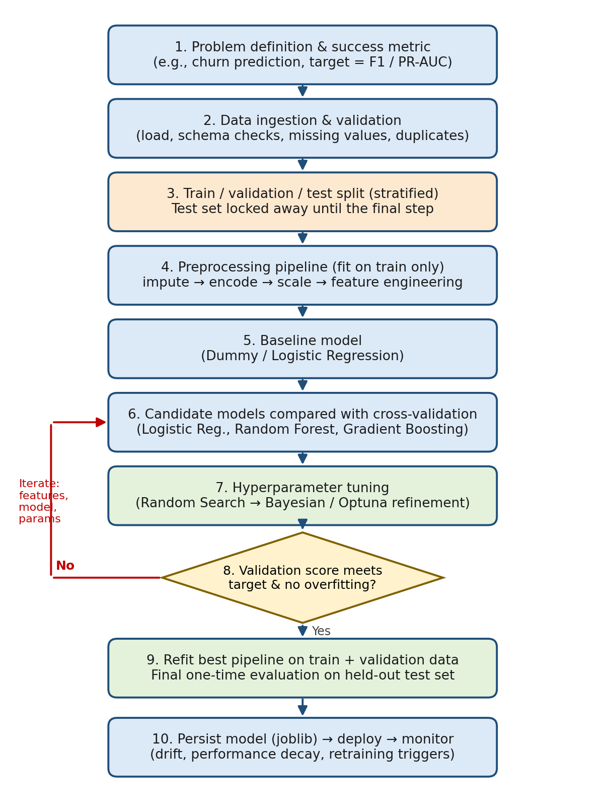
Figure 1. End-to-end model building and training pipeline

4.2 Pseudocode
PSEUDOCODE
FUNCTION build_and_train_model(data_source, config):

# 1. Ingest and validate
raw_data <- LOAD(data_source)
VALIDATE_SCHEMA(raw_data); DROP_LEAKAGE_COLUMNS(raw_data)

# 2. Split (test set is locked away)
X_train, X_test, y_train, y_test <- STRATIFIED_SPLIT(raw_data, test=0.15)

# 3. Preprocessing + model as ONE pipeline (no leakage)
preprocess <- COLUMN_TRANSFORMER(
numeric : [IMPUTE(median, add_indicator), SCALE],
categorical : [ONE_HOT_ENCODE(ignore unknown)])

# 4. Baseline and candidate comparison via cross-validation
candidates <- {Dummy, LogisticRegression, RandomForest, GradientBoosting}
FOR each model IN candidates:
scores <- CROSS_VALIDATE(PIPELINE(preprocess, model), X_train, y_train, k=5)
RECORD(model, MEAN(scores), STD(scores), fit_time)
DIAGNOSE(validation_curve, learning_curve) # bias vs variance

# 5. Hyperparameter tuning (cross-validated random search)
search <- RANDOM_SEARCH(PIPELINE(preprocess, best_family), config.space,
n_iter=20, cv=5, metric=PR_AUC)

# 6. Validate; iterate if targets not met
IF cv_score < config.target OR (train_score - cv_score) > config.max_gap:
RETURN TO feature engineering / model choice

# 7. Threshold from out-of-fold predictions and business cost
oof <- CROSS_VAL_PREDICT(search.best_model, X_train, y_train, k=5)
threshold <- ARGMIN over t of (c_FN * FN(oof, t) + c_FP * FP(oof, t))

# 8. One-time test evaluation, calibration, sanity checks
REPORT(EVALUATE(best_model, X_test, y_test, threshold), bootstrap CIs)
CHECK(calibration, permutation_importance, shuffled_labels, seed_stability)

# 9. Persist model + threshold; verify reload gives identical predictions
SAVE(best_model, threshold, version, data_hash, code_hash)

5. Worked Example: Executed Code, Outputs, and Results
This section runs the pipeline from Section 4 on a dataset. Each step shows the exact Python code, the console output captured when the code was run, and an interpretation. Long code lines are wrapped for display only. A small helper P() prints a line and logs it, and R is a dictionary collecting results for the charts. The complete script is delivered alongside this document as experiment.py. The model used for boosting is scikit-learn's HistGradientBoostingClassifier, the same algorithm family as LightGBM and XGBoost, because only scikit-learn was available in the run environment.
Important context. The data are simulated, not real customer records, because no external dataset could be downloaded in this environment. Simulation has a benefit: the true drivers of churn are known, so we can check whether the pipeline recovers them (Section 5.13). It also limits how far conclusions transfer to real data; Section 7.2 discusses this.
Setup (imports used throughout):
PYTHON CODE (as executed)
import os, time, pickle, warnings
import numpy as np, pandas as pd, joblib
from scipy.stats import loguniform, randint, uniform
from sklearn.base import clone
from sklearn.compose import ColumnTransformer
from sklearn.pipeline import Pipeline
from sklearn.impute import SimpleImputer
from sklearn.preprocessing import StandardScaler, OneHotEncoder
from sklearn.dummy import DummyClassifier
from sklearn.linear_model import LogisticRegression
from sklearn.ensemble import RandomForestClassifier, HistGradientBoostingClassifier
from sklearn.calibration import CalibratedClassifierCV, calibration_curve
from sklearn.inspection import permutation_importance
from sklearn.feature_selection import SelectKBest, f_classif
from sklearn.model_selection import (train_test_split, StratifiedKFold, cross_validate,
cross_val_predict, cross_val_score, RandomizedSearchCV, validation_curve, learning_curve)
from sklearn.metrics import (average_precision_score, roc_auc_score, f1_score, accuracy_score,
precision_score, recall_score, confusion_matrix, brier_score_loss, precision_recall_curve)
warnings.filterwarnings("ignore")

5.1 Dataset generation and inspection
The generator builds 12,000 customers with 11 features. Churn probability is a logistic function of contract type, tenure, monthly charges, support calls, late payments, and number of products, plus two interaction effects (fibre customers with charges above $85, and month-to-month customers in their first six months). The intercept is solved numerically so the overall churn rate is 20%. Missing values are then injected at random into two columns.
Feature | Type | Role in the simulation
tenure_months | Numeric | Longer tenure lowers churn risk
monthly_charges | Numeric | Higher charges raise risk; 3% missing
total_charges | Numeric | Approximately tenure × monthly charges (redundant by design)
support_calls_90d | Numeric (count) | More calls raise risk
late_payments | Numeric (count) | More late payments raise risk
num_products | Numeric (1 to 5) | More products lower risk
age | Numeric | No effect on churn (noise feature)
data_usage_gb | Numeric | No effect on churn (noise feature); 5% missing
contract | Categorical | Month-to-month raises risk; two-year lowers it
internet_service | Categorical | Fibre with high charges adds an interaction effect
payment_method | Categorical | Affects late payments only; no direct effect

PYTHON CODE (as executed)
rng = np.random.default_rng(SEED)
n = 12000
contract = rng.choice(["Month-to-month", "One year", "Two year"], n, p=[.55, .25, .20])
internet = rng.choice(["DSL", "Fiber", "None"], n, p=[.35, .45, .20])
payment = rng.choice(["Card", "Bank transfer", "E-check", "Mailed check"], n, p=[.3, .3, .25, .15])
tenure = np.clip(rng.gamma(2.0, 14, n), 1, 72).round()
monthly = np.clip(rng.normal(65, 25, n) + 15*(internet == "Fiber") - 30*(internet == "None"), 18,
120)
total = tenure * monthly * rng.normal(1, 0.05, n)
support = rng.poisson(1.2 + 0.8*(internet == "Fiber"))
late = rng.poisson(0.4 + 0.5*(payment == "E-check"))
age = rng.integers(18, 81, n)
products = rng.integers(1, 6, n)
usage = rng.lognormal(3.0, 0.8, n)
z = (1.3*(contract == "Month-to-month") - 0.9*(contract == "Two year") - 0.035*tenure
+ 0.018*(monthly - 65) + 0.30*support + 0.35*late - 0.22*products
+ 0.8*((internet == "Fiber") & (monthly > 85))
+ 0.9*((contract == "Month-to-month") & (tenure < 6)) + rng.normal(0, 0.5, n))
lo, hi = -10.0, 10.0
for _ in range(60): # find intercept giving ~20% churn
mid = (lo + hi) / 2
if (1/(1 + np.exp(-(z + mid)))).mean() > 0.20: hi = mid
else: lo = mid
y = pd.Series((rng.random(n) < 1/(1 + np.exp(-(z + mid)))).astype(int), name="churn")
X = pd.DataFrame({"tenure_months": tenure, "monthly_charges": monthly, "total_charges": total,
"support_calls_90d": support, "late_payments": late, "age": age, "num_products": products,
"data_usage_gb": usage, "contract": contract, "internet_service": internet,
"payment_method": payment})
X.loc[rng.random(n) < 0.05, "data_usage_gb"] = np.nan # inject realistic missingness
X.loc[rng.random(n) < 0.03, "monthly_charges"] = np.nan
P("Dataset shape:", X.shape, "| churn rate: %.1f%%" % (100*y.mean()))
P("Missing values (%):", (100*X.isna().mean()[lambda s: s > 0]).round(1).to_dict())

CONSOLE OUTPUT (real run)
Dataset shape: (12000, 11) | churn rate: 20.3%
Missing values (%): {'monthly_charges': 2.9, 'data_usage_gb': 4.6}

The target is imbalanced (20.3% churners), and two columns have missing values (2.9% and 4.6%), so the pipeline needs imputation and imbalance-aware evaluation.

5.2 Train/test split and preprocessing pipeline
PYTHON CODE (as executed)
X_train, X_test, y_train, y_test = train_test_split(X, y, test_size=0.15, stratify=y,
random_state=SEED)
P("Train: %d rows, churn %.1f%%" % (len(X_train), 100*y_train.mean()))
P("Test : %d rows, churn %.1f%%" % (len(X_test), 100*y_test.mean()))

num_cols = ["tenure_months", "monthly_charges", "total_charges", "support_calls_90d",
"late_payments", "age", "num_products", "data_usage_gb"]
cat_cols = ["contract", "internet_service", "payment_method"]
preprocess = ColumnTransformer([
("num", Pipeline([("imp", SimpleImputer(strategy="median", add_indicator=True)),
("sc", StandardScaler())]), num_cols),
("cat", OneHotEncoder(handle_unknown="ignore"), cat_cols)])
cv = StratifiedKFold(n_splits=5, shuffle=True, random_state=SEED)
def make(clf): return Pipeline([("prep", preprocess), ("clf", clf)])
SC = {"pr": "average_precision", "roc": "roc_auc", "f1": "f1"}

CONSOLE OUTPUT (real run)
Train: 10200 rows, churn 20.3%
Test : 1800 rows, churn 20.3%

A stratified split keeps the churn rate at 20.3% in both subsets. The test set (1,800 rows, 366 churners) is now locked away. The ColumnTransformer and the cross-validation object (5 folds, shuffled, seeded) are defined once and reused for every experiment, which guarantees that all models are compared on identical folds.

5.3 Baseline and the accuracy paradox
Before comparing real models, a trivial baseline shows why accuracy cannot be the metric. A model that always predicts "stay" is correct for 79.7% of test customers and finds none of the 366 churners (first line of the output in Section 5.4). Any metric that rewards this model is the wrong metric, so model selection uses PR-AUC, whose floor equals the churn rate (0.203).

5.4 Model comparison with cross-validation
PYTHON CODE (as executed)
dummy = make(DummyClassifier(strategy="prior")).fit(X_train, y_train)
P("Dummy (always predicts 'stay'): test accuracy = %.3f, recall = %.3f"
% (accuracy_score(y_test, dummy.predict(X_test)), recall_score(y_test, dummy.predict(X_test))))
cands = {
"Baseline (prior)": DummyClassifier(strategy="prior"),
"Logistic regression": LogisticRegression(max_iter=2000),
"Random forest": RandomForestClassifier(n_estimators=300, min_samples_leaf=3, n_jobs=-1,
random_state=SEED),
"Gradient boosting": HistGradientBoostingClassifier(random_state=SEED),
}
P("%-22s %-16s %-16s %-16s %s" % ("Model", "PR-AUC", "ROC-AUC", "F1@0.5", "Fit time/fold"))
R["cv_models"] = {}
for name, clf in cands.items():
t = time.time()
s = cross_validate(make(clf), X_train, y_train, cv=cv, scoring=SC)
R["cv_models"][name] = {k: (s["test_"+k].mean(), s["test_"+k].std()) for k in SC}
P("%-22s %.3f +/- %.3f %.3f +/- %.3f %.3f +/- %.3f %.1fs" % (name,
*R["cv_models"][name]["pr"], *R["cv_models"][name]["roc"], *R["cv_models"][name]["f1"],
(time.time()-t)/5))

CONSOLE OUTPUT (real run)
Dummy (always predicts 'stay'): test accuracy = 0.797, recall = 0.000
Model PR-AUC ROC-AUC F1@0.5 Fit time/fold
Baseline (prior) 0.203 +/- 0.000 0.500 +/- 0.000 0.000 +/- 0.000 0.0s
Logistic regression 0.542 +/- 0.035 0.809 +/- 0.014 0.413 +/- 0.035 0.0s
Random forest 0.528 +/- 0.033 0.800 +/- 0.015 0.399 +/- 0.038 2.3s
Gradient boosting 0.520 +/- 0.027 0.795 +/- 0.013 0.416 +/- 0.026 0.3s

Model (5-fold CV) | PR-AUC | ROC-AUC | F1 at 0.5
Baseline (prior) | 0.203 ± 0.000 | 0.500 ± 0.000 | 0.000 ± 0.000
Logistic regression | 0.542 ± 0.035 | 0.809 ± 0.014 | 0.413 ± 0.035
Random forest | 0.528 ± 0.033 | 0.800 ± 0.015 | 0.399 ± 0.038
Gradient boosting | 0.520 ± 0.027 | 0.795 ± 0.013 | 0.416 ± 0.026
Table 5.1. Cross-validated scores on the training set (mean ± standard deviation across folds). Highlighted: highest PR-AUC.
- All three models clearly beat the baseline: PR-AUC of 0.52 to 0.54 versus the 0.203 floor, a 2.5 to 2.7× improvement; ROC-AUC 0.80 to 0.81 versus 0.50.
- The models are statistically tied. Logistic regression leads (0.542), but the gap to gradient boosting (0.520) is smaller than one fold standard deviation (0.03).
- Our hypothesis was not confirmed. We expected boosting to win. It did not, because most signal in this data is additive in the log-odds, which logistic regression models directly; the two interaction effects are modest.
- Cost differs sharply: random forest needed 2.3 s per fold, boosting 0.3 s, and logistic regression under 0.1 s.
Takeaway. Complexity is not rewarded unless the data contain structure the simpler model cannot represent. The baseline-first habit exposed this immediately.

5.5 Handling class imbalance: what class weights change
PYTHON CODE (as executed)
P("%-34s %-10s %-10s %-10s %s" % ("Gradient boosting variant", "PR-AUC", "Precision", "Recall",
"F1"))
R["imb"] = {}
for name, cw in [("No class weights", None), ("class_weight='balanced'", "balanced")]:
s = cross_validate(make(HistGradientBoostingClassifier(class_weight=cw, random_state=SEED)),
X_train, y_train, cv=cv, scoring={"pr": "average_precision", "p": "precision", "r":
"recall", "f1": "f1"})
R["imb"][name] = {k: s["test_"+k].mean() for k in ["pr", "p", "r", "f1"]}
P("%-34s %-10.3f %-10.3f %-10.3f %.3f" % (name, *[R["imb"][name][k] for k in ["pr", "p", "r",
"f1"]]))

CONSOLE OUTPUT (real run)
Gradient boosting variant PR-AUC Precision Recall F1
No class weights 0.520 0.581 0.325 0.416
class_weight='balanced' 0.518 0.436 0.661 0.525

Class weights moved the operating point, not the model's ability to rank customers. Recall doubled (0.325 to 0.661), precision fell (0.581 to 0.436), and F1 improved (0.416 to 0.525), but PR-AUC, which is threshold-free, was unchanged (0.520 versus 0.518). Because threshold tuning achieves the same trade-off without altering the training objective, it is usually preferable. Section 5.12 shows the hidden cost: weighting destroys the probability scale.

5.6 Regularisation strength in logistic regression
PYTHON CODE (as executed)
P("%-10s %-14s %s" % ("C", "CV PR-AUC", "(smaller C = stronger L2 regularisation)"))
R["logreg_C"] = []
for C in [0.0001, 0.001, 0.01, 0.1, 1, 10, 100]:
s = cross_val_score(make(LogisticRegression(C=C, max_iter=2000)), X_train, y_train, cv=cv,
scoring="average_precision")
R["logreg_C"].append((C, s.mean(), s.std())); P("%-10g %.3f +/- %.3f" % (C, s.mean(), s.std()))

CONSOLE OUTPUT (real run)
C CV PR-AUC (smaller C = stronger L2 regularisation)
0.0001 0.498 +/- 0.029
0.001 0.523 +/- 0.032
0.01 0.541 +/- 0.034
0.1 0.542 +/- 0.035
1 0.542 +/- 0.035
10 0.542 +/- 0.035
100 0.542 +/- 0.035

With C = 0.0001 the penalty is so strong that coefficients are crushed and the model underfits (PR-AUC 0.498). Performance rises to a plateau at C ≥ 0.01 (0.541 to 0.542). The plateau exists because the dataset has 10,200 rows and about 20 encoded columns, so there is little room to overfit. Choosing the strongest regularisation on the plateau (C = 0.01) is the conservative choice, since it is equally accurate and more stable.

5.7 Diagnosing overfitting: validation curve
PYTHON CODE (as executed)
leaves = [3, 7, 15, 31, 63, 127, 255]
tr, va = validation_curve(make(HistGradientBoostingClassifier(max_iter=200, learning_rate=0.1,
early_stopping=False, random_state=SEED)), X_train, y_train, param_name="clf__max_leaf_nodes",
param_range=leaves, cv=cv, scoring="average_precision")
R["valcurve"] = (leaves, tr, va)
P("%-12s %-12s %-12s %s" % ("max_leaf_nodes", "Train PR-AUC", "CV PR-AUC", "Gap"))
for l, a, b in zip(leaves, tr.mean(1), va.mean(1)): P("%-12d %-12.3f %-12.3f %.3f" % (l, a, b, a-b))

CONSOLE OUTPUT (real run)
max_leaf_nodes Train PR-AUC CV PR-AUC Gap
3 0.585 0.545 0.041
7 0.674 0.534 0.140
15 0.811 0.516 0.296
31 0.954 0.502 0.452
63 0.999 0.493 0.506
127 1.000 0.488 0.512
255 1.000 0.482 0.518

Increasing tree size from 3 to 255 leaves drives training PR-AUC from 0.585 to 1.000, a perfect fit, while cross-validated PR-AUC falls from 0.545 to 0.482. The train-validation gap grows from 0.041 to 0.518, the classic signature of overfitting. The best complexity is the simplest setting tested. Figure 2 (left) plots the same data.
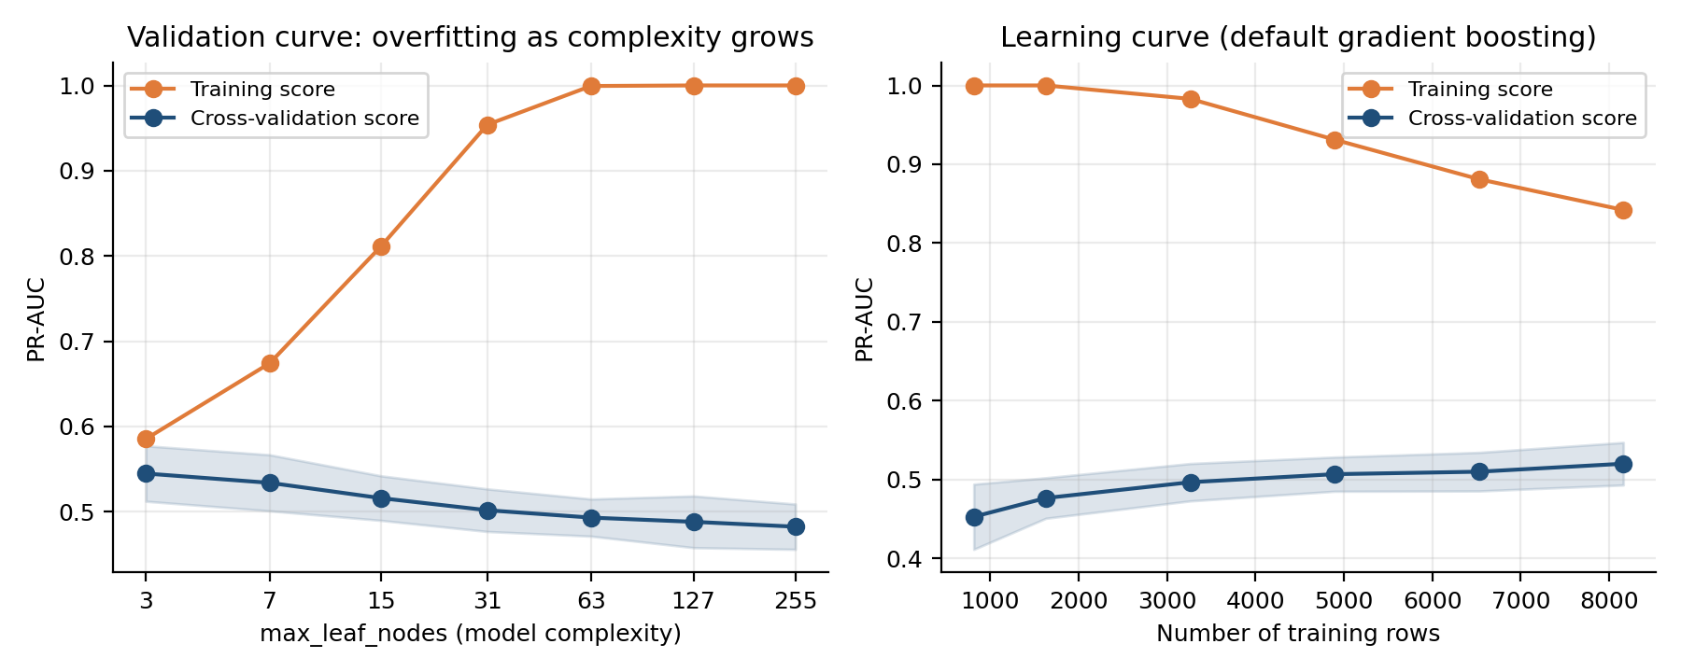
Figure 2. Left: validation curve over tree size. Right: learning curve for default gradient boosting.

5.8 Diagnosing data sufficiency: learning curve
PYTHON CODE (as executed)
sizes, tr, va = learning_curve(make(HistGradientBoostingClassifier(random_state=SEED)), X_train,
y_train,
train_sizes=[0.1, 0.2, 0.4, 0.6, 0.8, 1.0], cv=cv, scoring="average_precision",
random_state=SEED)
R["learning"] = (sizes, tr, va)
P("%-12s %-12s %s" % ("Train rows", "Train PR-AUC", "CV PR-AUC"))
for s_, a, b in zip(sizes, tr.mean(1), va.mean(1)): P("%-12d %-12.3f %.3f" % (s_, a, b))

CONSOLE OUTPUT (real run)
Train rows Train PR-AUC CV PR-AUC
816 1.000 0.453
1632 1.000 0.477
3264 0.983 0.497
4896 0.931 0.507
6528 0.881 0.510
8160 0.842 0.520

With 10× more training rows (816 to 8,160) the cross-validated score improved from 0.453 to 0.520, and the curve is still rising at the right edge (Figure 2, right). The default model's training score of 0.842 is far above its validation score of 0.520, so the model is in a high-variance regime. Two remedies follow: collect more data, or constrain the model, which is what tuning does next.

5.9 Hyperparameter tuning with random search
PYTHON CODE (as executed)
param_dist = {
"clf__learning_rate": loguniform(0.01, 0.3), "clf__max_iter": randint(100, 400),
"clf__max_leaf_nodes": randint(4, 48), "clf__min_samples_leaf": randint(10, 120),
"clf__l2_regularization": loguniform(1e-3, 10), "clf__max_features": uniform(0.4, 0.6)}
search = RandomizedSearchCV(make(HistGradientBoostingClassifier(early_stopping=False,
random_state=SEED)),
param_dist, n_iter=20, cv=cv, scoring="average_precision", random_state=SEED, refit=True)
t = time.time(); search.fit(X_train, y_train)
P("Random search: 20 configs x 5 folds = 100 fits in %.0f s" % (time.time() - t))
P("Default model CV PR-AUC : %.3f" % R["cv_models"]["Gradient boosting"]["pr"][0])
P("Tuned model CV PR-AUC : %.3f" % search.best_score_)
P("Best parameters:", {k.replace("clf__", ""): (round(float(v), 4) if isinstance(v, float) else
int(v))
for k, v in search.best_params_.items()})
res = pd.DataFrame(search.cv_results_).sort_values("rank_test_score").head(5)
P("\nTop-5 configurations:")
P("%-5s %-14s %-9s %-9s %-9s %-9s %s" % ("Rank", "CV PR-AUC", "lr", "n_iter", "leaves", "min_leaf",
"l2"))
for _, r_ in res.iterrows():
P("%-5d %.3f +/- %.3f %-9.3f %-9d %-9d %-9d %.3f" % (r_.rank_test_score, r_.mean_test_score,
r_.std_test_score,
r_.param_clf__learning_rate, r_.param_clf__max_iter, r_.param_clf__max_leaf_nodes,
r_.param_clf__min_samples_leaf, r_.param_clf__l2_regularization))
allscores = pd.DataFrame(search.cv_results_).mean_test_score
P("\nAll 20 configs: min %.3f, median %.3f, max %.3f" % (allscores.min(), allscores.median(),
allscores.max()))
R["search_scores"] = allscores.values
best = search.best_estimator_

CONSOLE OUTPUT (real run)
Random search: 20 configs x 5 folds = 100 fits in 70 s
Default model CV PR-AUC : 0.520
Tuned model CV PR-AUC : 0.542
Best parameters: {'l2_regularization': 0.4014, 'learning_rate': 0.0121, 'max_features': 0.8332,
'max_iter': 393, 'max_leaf_nodes': 5, 'min_samples_leaf': 73}

Top-5 configurations:
Rank CV PR-AUC lr n_iter leaves min_leaf l2
1 0.542 +/- 0.035 0.012 393 5 73 0.401
2 0.541 +/- 0.030 0.018 188 17 18 0.269
3 0.538 +/- 0.030 0.144 154 6 110 0.067
4 0.538 +/- 0.030 0.031 161 27 46 0.311
5 0.537 +/- 0.029 0.014 199 43 33 0.061

All 20 configs: min 0.469, median 0.516, max 0.542

- Tuning helped: CV PR-AUC rose from 0.520 (defaults) to 0.542, a gain of 0.022 (+4.2% relative), for 70 seconds of compute (20 configurations × 5 folds = 100 fits).
- Choices matter: across the 20 configurations the score ranged from 0.469 to 0.542 (median 0.516). A careless setting costs up to 0.07 PR-AUC.
- The winner is a heavily regularised model: 5 leaves per tree, learning rate 0.012, 393 rounds, at least 73 rows per leaf. This matches the validation curve in Section 5.7, where the smallest trees were best.
- The optimum is flat: the top five configurations lie within 0.005 of each other (0.542 to 0.537). Spending more compute on a finer search would yield little.

5.10 Choosing the decision threshold from business cost
Suppose a missed churner costs $300 in lost margin and a retention offer to a customer who would have stayed costs $40. Out-of-fold predictions on the training set (never the test set) are scanned over thresholds to find the F1-optimal and the cost-optimal values.
PYTHON CODE (as executed)
oof = cross_val_predict(best, X_train, y_train, cv=cv, method="predict_proba")[:, 1]
COST_FN, COST_FP = 300, 40 # lost margin of a missed churner vs cost of a wasted retention
offer
grid = np.linspace(0.02, 0.95, 94)
def at(th, p=oof, yy=y_train):
pred = (p >= th).astype(int); tn, fp, fn, tp = confusion_matrix(yy, pred).ravel()
return dict(th=th, prec=precision_score(yy, pred), rec=recall_score(yy, pred), f1=f1_score(yy,
pred),
cost=(COST_FN*fn + COST_FP*fp)/len(yy)*1000)
f1_th = grid[np.argmax([at(t_)["f1"] for t_ in grid])]
cost_th = grid[np.argmin([at(t_)["cost"] for t_ in grid])]
P("Out-of-fold predictions on the training set (cost: FN=$%d, FP=$%d)" % (COST_FN, COST_FP))
P("%-22s %-10s %-10s %-10s %-8s %s" % ("Rule", "Threshold", "Precision", "Recall", "F1", "Cost per
1,000 customers"))
R["thr_rows"] = {}
for name, th in [("Default 0.50", 0.50), ("F1-optimal", f1_th), ("Cost-optimal", cost_th)]:
a = at(th); R["thr_rows"][name] = a
P("%-22s %-10.2f %-10.3f %-10.3f %-8.3f $%s" % (name, th, a["prec"], a["rec"], a["f1"],
format(round(a["cost"]), ",")))
R["oof"] = oof; R["thr"] = dict(f1=f1_th, cost=cost_th)

CONSOLE OUTPUT (real run)
Out-of-fold predictions on the training set (cost: FN=$300, FP=$40)
Rule Threshold Precision Recall F1 Cost per 1,000 customers
Default 0.50 0.50 0.670 0.252 0.366 $46,629
F1-optimal 0.26 0.475 0.635 0.543 $27,992
Cost-optimal 0.14 0.333 0.861 0.481 $22,496

Rule | Threshold | Precision | Recall | F1 | Cost per 1,000 customers
Default 0.50 | 0.50 | 0.670 | 0.252 | 0.366 | $46,629
F1-optimal | 0.26 | 0.475 | 0.635 | 0.543 | $27,992
Cost-optimal | 0.14 | 0.333 | 0.861 | 0.481 | $22,496
Table 5.2. Operating points on out-of-fold predictions. Highlighted: lowest expected cost.
At the default 0.50 the model catches only 25% of churners, and the expected cost is $46,629 per 1,000 customers. The F1-optimal threshold (0.26) raises recall to 63.5%. The cost-optimal threshold (0.14) flags more customers (precision falls to 0.333) but recovers 86% of churners, and cuts expected cost by 52% relative to the default. The best metric-based threshold is not the best business threshold, because F1 treats a missed churner and a wasted offer as equally bad while the costs differ 7.5 to 1.

5.11 Final evaluation on the held-out test set
PYTHON CODE (as executed)
test_models = {n_: make(c).fit(X_train, y_train) for n_, c in cands.items() if n_ != "Baseline
(prior)"}
test_models["Gradient boosting (tuned)"] = best
test_models["Baseline (prior)"] = dummy
P("%-28s %-10s %s" % ("Model (held-out test set)", "PR-AUC", "ROC-AUC"))
R["test_scores"], R["test_proba"] = {}, {}
for name in ["Baseline (prior)", "Logistic regression", "Random forest", "Gradient boosting",
"Gradient boosting (tuned)"]:
pr_ = test_models[name].predict_proba(X_test)[:, 1]; R["test_proba"][name] = pr_
R["test_scores"][name] = (average_precision_score(y_test, pr_), roc_auc_score(y_test, pr_))
P("%-28s %-10.3f %.3f" % (name, *R["test_scores"][name]))
proba = R["test_proba"]["Gradient boosting (tuned)"]
pred = (proba >= f1_th).astype(int)
tn, fp, fn, tp = confusion_matrix(y_test, pred).ravel()
P("\nFinal model at F1-optimal threshold = %.2f" % f1_th)
P("Confusion matrix: TN=%d FP=%d FN=%d TP=%d" % (tn, fp, fn, tp))
P("Accuracy %.3f | Precision %.3f | Recall %.3f | F1 %.3f" % (accuracy_score(y_test, pred),
precision_score(y_test, pred), recall_score(y_test, pred), f1_score(y_test, pred)))
R["cm"] = (tn, fp, fn, tp)
yt = y_test.values; brng = np.random.default_rng(SEED); bs_pr, bs_f1 = [], []
for _ in range(1000):
idx = brng.integers(0, len(yt), len(yt))
bs_pr.append(average_precision_score(yt[idx], proba[idx])); bs_f1.append(f1_score(yt[idx],
pred[idx]))
P("95%% bootstrap CI PR-AUC: [%.3f, %.3f] F1: [%.3f, %.3f]" % (*np.percentile(bs_pr, [2.5,
97.5]), *np.percentile(bs_f1, [2.5, 97.5])))
order = np.argsort(-proba); top = order[:len(order)//10]
P("Top-decile lift: %.2fx (top 10%% of scores contain %.0f%% of all churners)" %
(yt[top].mean()/yt.mean(), 100*yt[top].sum()/yt.sum()))
a = at(cost_th, proba, y_test); b0 = at(0.5, proba, y_test)
P("Expected cost per 1,000 customers on test: threshold 0.50 -> $%s ; cost-optimal %.2f -> $%s ; no
model -> $%s" %
(format(round(b0["cost"]), ","), cost_th, format(round(a["cost"]), ","),
format(round(COST_FN*yt.mean()*1000), ",")))

CONSOLE OUTPUT (real run)
Model (held-out test set) PR-AUC ROC-AUC
Baseline (prior) 0.203 0.500
Logistic regression 0.572 0.827
Random forest 0.558 0.819
Gradient boosting 0.561 0.819
Gradient boosting (tuned) 0.571 0.823

Final model at F1-optimal threshold = 0.26
Confusion matrix: TN=1155 FP=279 FN=126 TP=240
Accuracy 0.775 | Precision 0.462 | Recall 0.656 | F1 0.542
95% bootstrap CI PR-AUC: [0.516, 0.621] F1: [0.501, 0.579]
Top-decile lift: 3.36x (top 10% of scores contain 34% of all churners)
Expected cost per 1,000 customers on test: threshold 0.50 -> $46,011 ; cost-optimal 0.14 -> $20,767 ; no
model -> $61,000

Model (test set, 1,800 rows) | PR-AUC | ROC-AUC
Baseline (prior) | 0.203 | 0.500
Logistic regression | 0.572 | 0.827
Random forest | 0.558 | 0.819
Gradient boosting | 0.561 | 0.819
Gradient boosting (tuned) | 0.571 | 0.823
Table 5.3. Held-out test performance. Highlighted: logistic regression and the tuned gradient boosting model.
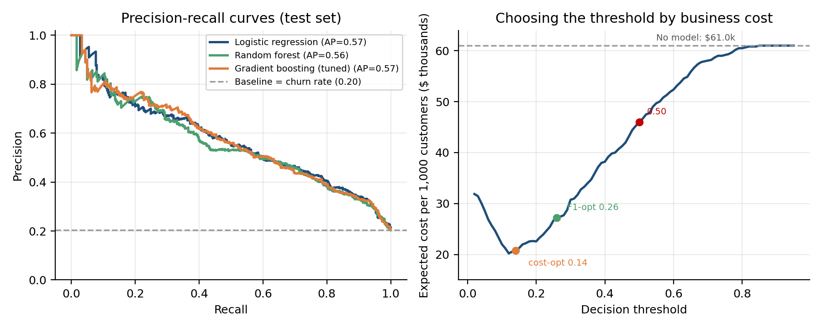
Figure 3. Left: precision-recall curves on the test set. Right: expected cost as a function of the decision threshold.
- Test results agree with cross-validation: tuned boosting scored 0.571 PR-AUC on the test set versus 0.542 in CV. The test score is a little higher, a reminder that a single estimate carries noise.
- Uncertainty is substantial: the 95% bootstrap interval for PR-AUC is [0.516, 0.621] and for F1 is [0.501, 0.579]. With 366 churners in the test set, models scoring 0.558 to 0.572 cannot be statistically separated; logistic regression (0.572) and tuned boosting (0.571) are effectively identical.
- At the F1-optimal threshold of 0.26 the final model finds 240 of 366 churners (recall 0.656) at precision 0.462, with 279 false alarms. Overall accuracy is 0.775, lower than the always-"stay" baseline's 0.797, yet the model is far more useful, which is the accuracy paradox again.
- Ranking value: the top-scored 10% of customers contain about a third of all churners (lift 3.36×), useful if retention capacity is limited.
- Business value: expected cost per 1,000 customers is $61,000 with no model, $46,011 with the model at threshold 0.50, and $20,767 at the cost-optimal threshold 0.14, a 66% reduction versus no model. Threshold selection contributed more of the saving than the choice of algorithm.
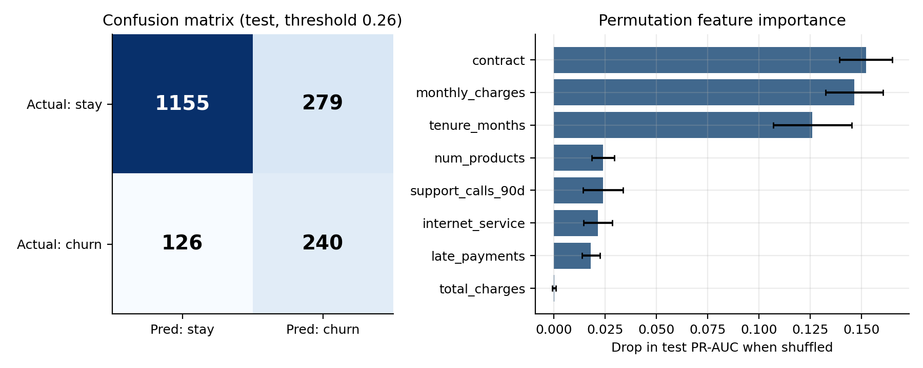
Figure 4. Left: confusion matrix at threshold 0.26. Right: permutation feature importance on the test set.

5.12 Probability calibration
PYTHON CODE (as executed)
def ece(yy, p, bins=10):
edges = np.linspace(0, 1, bins+1); idx = np.clip(np.digitize(p, edges) - 1, 0, bins-1); e = 0
for b_ in range(bins):
m = idx == b_
if m.any(): e += m.mean() * abs(yy[m].mean() - p[m].mean())
return e
bal = clone(best).set_params(clf__class_weight="balanced").fit(X_train, y_train)
iso = CalibratedClassifierCV(clone(best), method="isotonic", cv=5).fit(X_train, y_train)
P("%-36s %-12s %s" % ("Model (test set)", "Brier score", "ECE (10 bins)"))
R["calib"] = {}
for name, m in [("Tuned (no class weights)", best), ("Tuned + class_weight='balanced'", bal),
("Tuned + isotonic calibration", iso)]:
p_ = m.predict_proba(X_test)[:, 1]; R["calib"][name] = (p_, brier_score_loss(yt, p_), ece(yt,
p_))
P("%-36s %-12.4f %.4f" % (name, R["calib"][name][1], R["calib"][name][2]))
P("Reference: Brier score of a constant prediction of the base rate = %.4f" % brier_score_loss(yt,
np.full(len(yt), yt.mean())))

CONSOLE OUTPUT (real run)
Model (test set) Brier score ECE (10 bins)
Tuned (no class weights) 0.1231 0.0306
Tuned + class_weight='balanced' 0.1787 0.2258
Tuned + isotonic calibration 0.1219 0.0199
Reference: Brier score of a constant prediction of the base rate = 0.1620

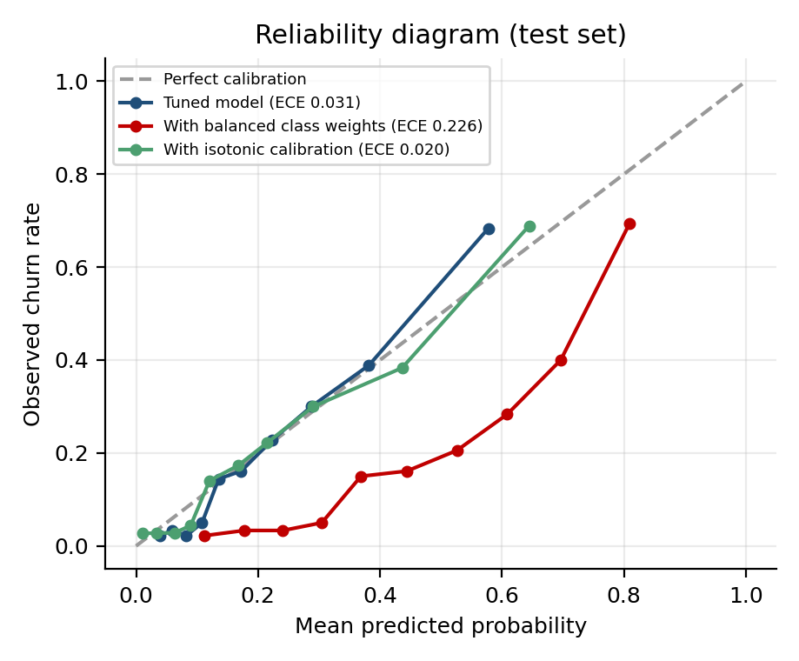
Figure 5. Reliability diagram: observed churn rate versus predicted probability.
- The tuned model is already well calibrated: Brier score 0.1231 (24% better than the 0.1620 of a constant base-rate prediction) and ECE 0.031.
- Class weights break calibration: with class_weight="balanced" the Brier score worsens to 0.1787, worse than the constant prediction, and ECE jumps to 0.226. A customer scored at 0.8 does not churn 80% of the time. If probabilities feed expected-value calculations, this model would mislead.
- Isotonic calibration helps only marginally (Brier 0.1219, ECE 0.020), so it is optional here. Calibrate when the diagnostic shows a problem, not by habit.

5.13 Which features matter?
PYTHON CODE (as executed)
pi = permutation_importance(best, X_test, y_test, scoring="average_precision", n_repeats=5,
random_state=SEED)
imp = pd.Series(pi.importances_mean, index=X_test.columns).sort_values(ascending=False)
sd = pd.Series(pi.importances_std, index=X_test.columns)
P("Permutation importance (drop in test PR-AUC when the feature is shuffled)")
for f, v in imp.items(): P("%-20s %.4f +/- %.4f" % (f, v, sd[f]))
R["imp"] = (imp, sd)

CONSOLE OUTPUT (real run)
Permutation importance (drop in test PR-AUC when the feature is shuffled)
contract 0.1521 +/- 0.0128
monthly_charges 0.1465 +/- 0.0140
tenure_months 0.1261 +/- 0.0191
num_products 0.0239 +/- 0.0055
support_calls_90d 0.0239 +/- 0.0098
internet_service 0.0215 +/- 0.0070
late_payments 0.0181 +/- 0.0044
total_charges 0.0002 +/- 0.0008
age 0.0000 +/- 0.0001
data_usage_gb 0.0000 +/- 0.0000
payment_method 0.0000 +/- 0.0000

Permutation importance measures how much test PR-AUC drops when a feature's values are shuffled. Contract type (0.152), monthly charges (0.147), and tenure (0.126) dominate, followed by number of products, support calls, internet service, and late payments (0.018 to 0.024). Age, data usage, and payment method score essentially zero. This matches the data-generating process exactly: the simulation gave those three features no direct effect. Recovering known structure is evidence that the pipeline is learning real signal. Total charges also scores near zero, not because it is irrelevant but because it is almost a product of tenure and monthly charges, so shuffling it loses little that the other two do not already carry. Permutation importance should be read with this caveat for correlated features.

5.14 Sanity checks and a leakage demonstration
PYTHON CODE (as executed)
shuf = cross_val_score(clone(best), X_train, y_train.sample(frac=1, random_state=SEED).values,
cv=cv, scoring="average_precision")
P("Shuffled-label check: CV PR-AUC = %.3f (base rate = %.3f; real labels = %.3f)" % (shuf.mean(),
y_train.mean(), search.best_score_))
seeds = []
for s_ in range(5):
m = clone(best).set_params(clf__random_state=s_).fit(X_train, y_train)
seeds.append(average_precision_score(y_test, m.predict_proba(X_test)[:, 1]))
P("Seed stability (5 seeds) test PR-AUC: " + ", ".join("%.3f" % v for v in seeds) + " -> mean %.3f,
std %.4f" % (np.mean(seeds), np.std(seeds)))
r2 = np.random.default_rng(0); Xn = r2.normal(size=(100, 2000)); yn = r2.integers(0, 2, 100)
wrong = cross_val_score(LogisticRegression(max_iter=500), SelectKBest(f_classif,
k=20).fit_transform(Xn, yn), yn, cv=5).mean()
right = cross_val_score(Pipeline([("sel", SelectKBest(f_classif, k=20)), ("lr",
LogisticRegression(max_iter=500))]), Xn, yn, cv=5).mean()
P("Leakage demo (pure noise, 100 rows x 2000 features, true accuracy = 50%):")
P(" feature selection BEFORE cross-validation : accuracy = %.2f (falsely high)" % wrong)
P(" feature selection INSIDE the pipeline : accuracy = %.2f (honest)" % right)
R["leak"] = (wrong, right)

CONSOLE OUTPUT (real run)
Shuffled-label check: CV PR-AUC = 0.209 (base rate = 0.203; real labels = 0.542)
Seed stability (5 seeds) test PR-AUC: 0.570, 0.569, 0.571, 0.570, 0.571 -> mean 0.570, std 0.0007
Leakage demo (pure noise, 100 rows x 2000 features, true accuracy = 50%):
feature selection BEFORE cross-validation : accuracy = 0.78 (falsely high)
feature selection INSIDE the pipeline : accuracy = 0.59 (honest)

- Shuffled labels: with outcomes randomly permuted, CV PR-AUC collapses to 0.209, essentially the base rate of 0.203, versus 0.542 with real labels. The score reflects genuine signal, and no leakage path exists in the pipeline.
- Seed stability: across five random seeds, test PR-AUC varied between 0.569 and 0.571 (std 0.0007), so the result is not a lucky seed.
- Leakage: on pure noise (true accuracy is 50%), selecting the 20 "best" features from the full dataset before cross-validation produced 0.78 accuracy, a 28-point illusion. Doing the same selection inside the pipeline gave 0.59, close to chance (the residual 9 points reflect small-sample luck with only 100 rows). This is why every data-dependent step belongs inside the cross-validated pipeline.

5.15 Persisting the model
PYTHON CODE (as executed)
joblib.dump({"model": best, "threshold": float(f1_th)}, "churn_model_v1.joblib")
art = joblib.load("churn_model_v1.joblib")
same = np.allclose(art["model"].predict_proba(X_test)[:, 1], proba)
P("Saved churn_model_v1.joblib (%.0f KB); reloaded predictions identical: %s" %
(os.path.getsize("churn_model_v1.joblib")/1024, same))
R["y_test"] = yt; R["f1_th"] = f1_th
pickle.dump(R, open("results.pkl", "wb"))
P("DONE")

CONSOLE OUTPUT (real run)
Saved churn_model_v1.joblib (286 KB); reloaded predictions identical: True
DONE

The artefact stores the whole fitted pipeline (imputer, scaler, encoder, model) together with the threshold. Reloading it reproduces identical predictions, which confirms that serving will apply exactly the transformations used in training and rules out train/serve skew from preprocessing.

5.16 Summary of measured results
Model | CV PR-AUC (train) | Test PR-AUC | Test ROC-AUC
Baseline (prior) | 0.203 ± 0.000 | 0.203 | 0.500
Logistic regression | 0.542 ± 0.035 | 0.572 | 0.827
Random forest | 0.528 ± 0.033 | 0.558 | 0.819
Gradient boosting (defaults) | 0.520 ± 0.027 | 0.561 | 0.819
Gradient boosting (tuned) | 0.542 ± 0.035 | 0.571 | 0.823
Table 5.4. Cross-validation versus held-out test results for every model.
Decision. The tuned boosting model is the one carried through threshold selection, calibration, and persistence in this document because it exercises the full tuning workflow. In a real deployment, the evidence points to logistic regression: it ties the tuned ensemble on test PR-AUC (0.572 versus 0.571), fits in under 0.1 s, and is directly interpretable. Applying the rule "if models are within noise, choose the simpler one" would select it. Boosting would become the better choice if richer interaction features, more data, or non-linear signals were added.

6. Best Practices and Common Pitfalls
Each pitfall below is paired with the evidence measured in Section 5 and the safeguard used.
Pitfall | Measured evidence (Section 5) | Safeguard used
Wrong metric (accuracy) | Always-"stay" model: 79.7% accuracy, 0% recall. Final model: 77.5% accuracy but finds 66% of churners. | PR-AUC for model selection; recall and cost for the operating point.
Data leakage | Selection before CV on noise: 0.78 accuracy versus 0.59 inside the pipeline (truth 0.50). | All preprocessing and selection inside the Pipeline; split before anything else.
Overfitting | Training PR-AUC 1.000 versus CV 0.482 at 255 leaves; gap of 0.518. | Validation curve, shallow trees, min_samples_leaf, L2 penalty.
Over-complex model | Logistic regression (0.572) matched tuned boosting (0.571) on test. | Baseline first; choose the simpler model when within noise.
Using class weights blindly | Brier score 0.123 became 0.179; ECE 0.031 became 0.226; PR-AUC unchanged. | Threshold tuning instead; calibration check before using probabilities.
Default 0.5 threshold | Cost per 1,000 customers: $46,629 at 0.50 versus $22,496 at the cost-optimal 0.14. | Choose the threshold on out-of-fold predictions using business costs.
Over-reading small differences | Fold std ≈ 0.03; test PR-AUC 95% CI [0.516, 0.621]. | Report intervals; compare models only beyond the noise.
Tuning on test data | Not applicable by construction: the test set was used once. | Tuning via CV on training data; threshold from out-of-fold predictions.
Irreproducible results | Five seeds gave test PR-AUC 0.569 to 0.571. | Fixed seeds, seed-stability check, script delivered with the report.
Train/serve skew | Reloaded artefact reproduced predictions exactly. | One serialised pipeline containing preprocessing, model, and threshold.
Silent degradation after launch | Not measurable offline. | Monitor drift and performance; define retraining triggers.

7. Conclusion

7.1 Summary of methodology and key findings
The plan moved from problem framing to model selection, a leakage-safe scikit-learn pipeline, cross-validated comparison, diagnosis of bias and variance, random-search tuning, cost-based threshold selection, a single test-set evaluation, and a battery of sanity checks. Running it on a 12,000-customer churn dataset produced these findings:
- A baseline-first approach showed that accuracy is useless here: 79.7% for a model that finds no churners.
- All models reached about 0.52 to 0.54 cross-validated PR-AUC (2.5 to 2.7× the 0.203 floor), and the differences were within one fold standard deviation. Logistic regression was as good as boosting.
- Tuning improved gradient boosting from 0.520 to 0.542 CV PR-AUC in 70 seconds, by selecting a strongly regularised, shallow-tree model consistent with the overfitting seen in the validation curve.
- The decision threshold mattered more than the algorithm: cost-optimal thresholding cut expected cost from $46,011 to $20,767 per 1,000 customers on the test set, against $61,000 with no model.
- The final model reached test PR-AUC 0.571 (95% CI 0.516 to 0.621), ROC-AUC 0.823, recall 0.656 at precision 0.462 (F1 0.542), and 3.36× lift in the top decile.
- Class weights shifted the operating point without improving ranking and badly distorted calibrated probabilities (Brier 0.123 to 0.179).
- Sanity checks passed: shuffled-label score equalled the base rate, results were stable across seeds, and the saved model reproduced its predictions.

7.2 Limitations
- Simulated data. Real churn data contain richer structure, label noise, and drift. The finding that logistic regression ties boosting is a property of this simulation's mostly additive signal and should not be generalised; on data with strong interactions boosting typically pulls ahead.
- Single dataset and split. Results come from one train/test partition. Repeated cross-validation or several datasets would give firmer conclusions.
- Limited test set. With 366 positives in the test set the confidence intervals are wide.
- Assumed costs. The $300 and $40 costs are illustrative; real values from finance and marketing would change the optimal threshold.
- Library scope. scikit-learn's HistGradientBoostingClassifier stood in for LightGBM or XGBoost, and random search for Bayesian optimisation, because those packages were unavailable. Nested cross-validation and SHAP explanations were not run.

7.3 Potential improvements
- Better data and features: tenure-normalised usage trends, recency features, and interaction terms (fibre × high charges) added to the linear model would likely close or reverse the small gap in boosting's favour.
- Stronger evaluation: repeated or nested cross-validation, paired significance tests between models, and a time-based split on real data.
- Automated search: Optuna with pruning, or AutoML (FLAML, AutoGluon), and multi-objective studies that balance accuracy against latency.
- Ensembling: a stack of logistic regression and boosting, since they make different kinds of errors.
- Explainability and fairness: SHAP explanations per customer and performance audits across customer segments.
- Uplift modelling: predict who will respond to a retention offer, not just who will churn, to target spending more precisely.
- MLOps maturity: CI/CD for models, feature stores, drift dashboards, champion-challenger testing, and automated retraining.

7.4 Reproducibility
All results come from one script run with fixed seeds (random_state = 42) on a single CPU core; the full pipeline, including 100 tuning fits, runs in about three minutes. The script (experiment.py) writes the saved model and a results file, and a second script (plots.py) draws the figures. Package versions are listed on the title page.

7.5 Further reading
- scikit-learn User Guide: Cross-validation, Tuning hyper-parameters, Probability calibration, Pipelines and composite estimators.
- Hastie, Tibshirani, Friedman. The Elements of Statistical Learning.
- Bergstra and Bengio (2012). Random Search for Hyper-Parameter Optimization. Journal of Machine Learning Research.
- Davis and Goadrich (2006). The Relationship Between Precision-Recall and ROC Curves.
- Geron, A. Hands-On Machine Learning with Scikit-Learn, Keras and TensorFlow.

